FS2 Open Ended Homework Grid 2020-2021 For more information about the curriculum, visit the school website <https://www.colburn.n-yorks.sch.uk/>

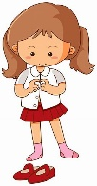

**Understanding**

**the World**

People who help us

Seasonal change.

**Ways to help at home**

Going on a nature walk.

Discussing the weather.

Discussing different celebrations/cultures.

Talk about different jobs.

**Personal, Social, Emotional Development**

Continue developing independence.

Confident to speak about their opinions and listen to others.

Begin to solve problems independently.

Discuss and share our feelings.

**Ways to help at home**

How they can solve problems.

Discuss what they enjoy doing and how this makes them feel.

Talk about differences between themselves and others in the family.

**Physical Development**

Gross motor skills.

Fine motor skills.

Dressing and undressing independently.

Forming letters correctly

**Ways to help at home**

Using a knife and fork.

Getting dressed independently.

Drawing and colouring in.

**Communication**

Listening and following instructions.

Speaking in sentences.

Using language to organise thinking.

**Ways to help at home**

Talking about what they have been doing.

Playing listening games such as I spy and Simon Say’s.



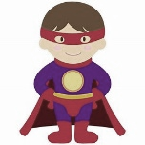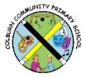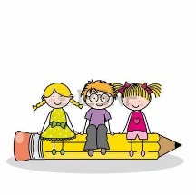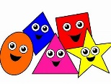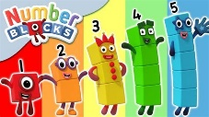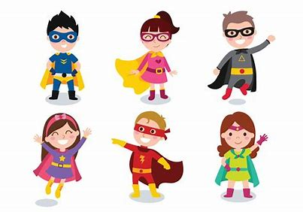

**Expressive Arts and Design**

Exploring colour mixing.

Using various tools safely and competently.

Playing alongside others to act out a narrative..

Joining in with and learning new songs and keeping the beat.

**Ways to help at home**

Listening to music and learning new songs.

Making up stories about toys they are playing with.

Dressing up and pretending to be a superhero.

Design and make your own superhero costume.

Autumn 2

Superheroes!

**Literacy**

Review phase 2 sounds.

Learn to read phase 3 sounds. (Digraphs, 2 letters one sound.)

Blending words and becoming confident at reading short sentences.

Read and spell some high frequency words.

Forming letters correctly.

Write labels and captions.

Begin to use finger spaces.

**Ways to help at home**

Read lots of different stories and ask questions about them.

Write shopping lists, write a name for a superhero and write about what powers they have.

Ask them about different letters in the environment.

Learn to read; **to, the, I, go, no, he, she** by sight

**Mathematics**

We continue our mastery of numbers. Children learn everything about a number; one more, one less, to recognise the number, numbers that go together to make the number.

To recognise and name different shapes and make patterns.

**Ways to help at home**

Count out different amounts of objects.

Go on a number hunt.

Find the total of two groups of objects (up to 10).

Find different ways of making five in your house.

Asking number problems eg. If I had had three footballs how many would I need to have six.

Go on a shape hunt- which shapes can you find the most of?