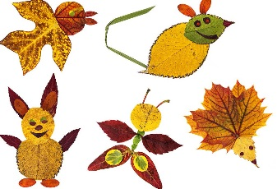

**RE**

This half term, the children will be learning about **The Christmas Story.**

**Key Vocabulary**: Jesus, Mary, Joseph, stable, manger, shepherds, angel, wise men

***Learning at home ideas****:*

* Read the Christmas story or watch it online.
* Draw and write about what gift you would give to a new baby.
* Draw a scene from the nativity and write speech bubbles for the people.

**Reading at home**

Children should practise the reading the high frequency words that they are learning in school.

This half term, we are learning;

went, from, children, little, it’s, just, help, said, were, out, like, have, one, do, when, some, come, there, what, so

Children should, as always, be reading lots! Taking responsibility for reading and ticking off your shopping lists when shopping, reading the recipes when cooking, or even reading their own bed time stories!

**Spelling at home**

Children should practise the spelling the high frequency words that they are learning in school.

This half term, we are learning;

he, she, we, me, be, you, all, are, her, was, they, my

**We would love you to share any learning and work done at home with us in school.**

**History**

This half term, the children will be learning about **Toys.**

**Key Vocabulary**: then, now, past, present, old, new

***Learning at home ideas:***

* Ask a grandparent or elderly relative about their favourite toy when they were little.
* Draw a picture of your favourite toy and write sentences to describe it.

**PSHCE**

This half term, the children will be learning about **Me and My Relationships.**

**Key Vocabulary**: family, care, love, respect, safety, security, worries, concerns

***Learning at home ideas:***

* Talk about who is in your family and how different people are related e.g. how grandma is related to mum… she is mum’s mum!
* Talk about online safety and what is okay and not okay when online. Discuss who you should talk to if you are concerned about something.

**Maths at home**

* Number hunt… what numbers can you see in your house?
* Discussing quantities using the language of ‘most’ and ‘least’ and ‘more’ and ‘less’. E.G. Who has more biscuits?
* Practise counting. Building up slowly… practise counting to 20… then when that can be done, practise counting to 30, then 40 etc.
* Play ‘Eye Spy’ with shapes. E.g. ‘Eye spy with my little eye, a circle’… what is the circle shape spotted?

*Homework will be set each week using MyMaths. Each child will have an individual login.*

**Science**

This half term, the children will be learning about **The seasons.**

**Key Vocabulary**: Summer, Winter, Autumn, Spring, change, weather, temperature

***Learning at home ideas****:*

* Use a device to look at the daily weather and temperature forecast.
* Keep a weather chart to record the weather.
* Collect Autumn leaves and make a picture with them.

Discuss why the leaves have fallen from the trees.