**Maths at home**

* Read and write numbers up to 100.
* Compare prices of items. What is more or less?
* See how quickly you can count to 50 in 5s and 100 in 10s
* Play a board game counting how many spaces you move or count pieces of a puzzle.
* Count pairs of socks in two’s.
* Practice how quickly you can do your number bonds to 10.

*Homework will be set each week using MyMaths. Each child will have an individual login.*

**Art**

**We are going to be looking at the artist Pablo Picasso-**

* **Create a fact file about Piccaso**
* **Find one of his pictures and copy**
* **Create a self-portrait.**

**Science**

This half term, the children will be learning about **Animals (including humans).**

***Key Vocabulary****: Offspring, grow, adults, nutrition, reproduce, lifecycle*

***Learning at home ideas****:*

* Choose an animal and draw its lifecycle
* Look at baby pictures of when you were younger – What did you eat back then? What did you play with? How did you move?
* Create a poster showing what you would need to survive on a desert island.

**Geography**

This term we will be looking at the local town of Catterick Garrison

***Key Vocabulary****: aerial, landscape, human geography, physical geography*

***Learning at home ideas:***

* Find Catterick Garrison on google maps. How long would it take to get there?
* List any of the shops or places in Catterick Garrison
* What are all the different ways you could travel to Catterick Garrison?

**Spelling at home**

Children should continue to orally practise the year 1/2 common exception spelling words – orally reciting the spellings and putting them into sentences will support their retention skills of the spelling patterns.

Identify spellings in and around the home.

Misspell some words – can they identify where you have gone wrong?

* Find out the main characters in the story
* What is Scrooge like at the beginning and then at the end of the story?
* Create your own ghost to visit Scrooge.

**English**

This half term, the children will be looking at story A Christmas Carol

***Learning at home ideas:***

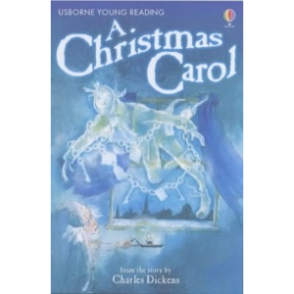

**History**

We have been looking at transport through the ages

**At home**-

Create and label your own model of transport – You can draw a picture or make it out of junk modelling.

**Reading at home**

Children should read a variety of texts e.g. recipes, newspapers, online blogs, Newsround, narratives and non-fiction texts. If they come across an unfamiliar word, children to find the meaning of the word through dictionaries or discussion with an adult. Tell an adult about what you have read or learnt. Children can read to an adult, to their pets or even their favourite toys.

**We would love you to share any learning and work done at home with us in school.**